Report Title (Arial 12)
approved DD Month YYYY (Arial 9)
ECC Report <No>
[last updated: DD Month YYYY] (Arial 9)

Executive summary – see A3.2.1

TABLE OF CONTENTS – SEE A3.2.2

0 Executive summary – see A3.2.1 2
1 Introduction – see A3.2.4 5
2 Definitions (optional section) - see A3.2.5 6
3 main chapters and its subsections – see A3.4.1 7
4 Conclusions – see A3.2.1 8
ANNEX 1: main annex chapters and its subsections – see A3.4.2 9
ANNEX 2: List of References - see A3.2.6 10
ANNEX 3: ECO instructions for the ECC Report template 11
A3.1 Introduction and general guidance 11
A3.1.1 Instructions on abbreviations 11
A3.1.2 Instructions on the template 11
A3.2 Instructions for specific sections 11
A3.2.1 Executive summary and conclusions 11
A3.2.2 Table of contents 12
A3.2.3 List of abbreviations 12
A3.2.4 Introduction 12
A3.2.5 Definitions 12
A3.2.6 List of references 12
A3.2.6.1 Information about references to ECC deliverables: 12
A3.3 Style for referring to other publications inside the Report 14
A3.4 Headings, lists and formatting 14
A3.4.1 Headings 14
A3.4.2 Annex headings 15
A3.4.3 New styles 16
A3.4.4 Removing styles 16
A3.4.5 Example of bulleted lists 16
A3.4.6 Example of numbered lists 16
A3.4.7 Example of lettered lists 17
A3.4.8 List of styles used in the ECC Deliverables Template shown in alphabetical order 17
A3.5 Figures 18
A3.5.1 General instructions for figures 18
A3.5.2 How to insert a figure caption 19
A3.5.3 Example of a figure 20
A3.6 Tables 20
A3.6.1 General instruction for tables 20
A3.6.2 How to insert a table caption 21
A3.6.3 How to insert a table 21
A3.6.4 Information on different kind of tables 22
A3.7 Equations¨ 23
A3.7.1 General information about equations 23
A3.7.2 Instructions for Equations with automatic numbering 23
A3.7.3 Example of an equation 25
A3.8 Flow of ECC deliverables 26

LIST OF ABBREVIATIONS - see A3.2.3

Abbreviation | Explanation (style: ECC Table Header red font)
CEPT | European Conference of Postal and Telecommunications Administrations
ECC | Electronic Communications Committee
<abbrev> | <explanation – edit the table as necessary>

Introduction – see A3.2.4

Definitions (optional section) - see A3.2.5

Term | Definition
ECC Table text | ECC Table text
ECC Table text | ECC Table text
ECC Table text | ECC Table text

main chapters and its subsections – see A3.4.1

Conclusions – see A3.2.1

- main annex chapters and its subsections – see A3.4.2
- List of References - see A3.2.6

- ECO instructions for the ECC Report template
  - Introduction and general guidance
This annex contains instructions on the use of the ECC Report template. Please read carefully before commencing work on a new draft ECC Report. This annex should be deleted before finalisation of the document. It is suggested to save a separate copy of these instructions for reference.

- Consider the ECC Style Guide and Use of ECC brand identity;
- Passive voice is used in the ECC deliverables (see ECC Style Guide 2.2);
- Frequency ranges are normally written as “1500-1700 MHz”. In some specific cases “from 1500 to 1700 MHz” can be used;
- The language is British English (see ECC Style Guide 2.4) – note in particular “-ise” instead of “-ize” – e.g. “harmonise”, “desensitise”;
- Write numbers ‘one’ to ‘nine’ and ‘first’ to ‘ninth’ in full. 10 and above should appear as figures. Use preferably the following convention for numbers. Example of a number: “100000.00” (see ECC Style Guide 2.8). No separators used for large numbers, decimal points should use a dot “.”, 2 decimal places preferred (where applicable);
- Units should be separated with a space, e.g. “5 m”, 60 dB” or “45 MHz”. Emission limits specified per bandwidth are written as “10 dBm/kHz” or “10 dBm/(4 kHz)”
- Date format: “23 November 2011” (see ECC Style Guide 2.7);
    - Instructions on abbreviations
- Abbreviations (uncapitalised) should be spelt out the first time they are used in the document, e.g.: "fixed service (FS)"., with the exception of commonly understood terms. Note special format for “e.i.r.p.”, “pfd”
- Radiocommunications services are uncapitalised (“fixed service”, “mobile service”), also “base station” and “earth station”
    - Instructions on the template
- For assistance on an introduction and an overview of the template, please contact the ECO expert;
- For issues with the locked template, please contact editorial@eco.cept.org. You may contact ECO when the problem occurs or you may request a future booking. ECO usually replies within one working day;
- ECO is to review the final deliverable before it is submitted to the Working Group:
The correct template must be used;
The list of abbreviations must be finalised and consistent with abbreviations used;
The list of references must be finalised and consistent, see example in A3.2.6;
ECO needs to have at least two working days for finalising the editorial work before it is submitted to the Working Group.
  - Instructions for specific sections
    - Executive summary and conclusions
The Executive Summary should provide a short and concise explanation on the purpose of the respective ECC Report and should clearly indicate the covered subjects to which it applies. In addition, it should clearly explain the application of the document.
A conclusion may review the main points of the ECC Report. A conclusion might elaborate on the results of the ECC Report and suggest extensions. Typically the main conclusions are also included in the executive summary.
    - Table of contents
- All annex headings level 1-3 appear in table of contents by default in order to assist with editing. For reports with long annexes this may be amended during final approval if necessary - please inform the ECO;
- This is automatically styled and compiled from the headings, subheadings and page numbers from the document that follows. To update the Table of Contents move cursor within the table and press F9.
    - List of abbreviations
- During drafting phase and public consultation, the table format will appear with a frame for ease of editing;
- Before publication, ECO will reformat the table without visible frames;
- The rapporteur is to add all abbreviations, references and explanations before the draft is submitted to the working group for public consultation approval;
- During public consultation, ECO will only check consistency in the list of abbreviations;
- Organisations’ names are to be written in English where applicable.
- If translated English titles of national organisations are used include the country name in brackets, e.g.:
BNetzA = Federal Network Agency (Germany);
ANFR = National Frequency Agency (France)
    - Introduction
The introduction should succinctly provide the background and context to the work and outline the main aims of the report.
    - Definitions
- if the Definitions (optional section) is not used, it has to be deleted.
    - List of references
- The List of references is always the last annex of the ECC Report;
- The rapporteur is to add all list of references before the draft is submitted to the working group for public consultation approval;
- During public consultation, ECO will only check consistency in the list of references;
- Titles are to be copied in as they appear in the source, so spelling and numbering may be different from the standard ECC style;
- If hyperlinks are provided the full link must be shown;
- The rapporteur is to decide and add version number and date if relevant.
      - Information about references to ECC deliverables:
- If a draft version of an ECC deliverable is used, the reference has to show that a draft version is used. A footnote shall be added and the text “expected to be approved MM YYYY”. ECO keeps track of this and will update in https://docdb.cept.org/ accordingly;
- Only approved ECC deliverables should be referenced. ECC input documents are only used as a reference in exceptional cases;
- ECO is to keep a copy of the file together with the approved ECC deliverable in case of external requests.
- For cases of multiple references to the same document within the main body, only include cross-references the first time on each page or sub-section. In tables, cross references are allowed on each line (see above example).Examples of references
For an ECC Report:
- ECC Report 217: "The Use of Land, Maritime and Aeronautical Earth Stations on Mobile Platforms Operating with NGSO FSS Satellite Systems in the Frequency Range 17.3-20.2 GHz, 27.5-29.1 GHz and 29.5-30.0 GHz”, approved February 2015, latest amendment January 2020

For an ECC Recommendation:
- ECC Recommendation (15)01: “Cross-border coordination for Mobile/Fixed Communications Networks (MFCN) in the frequency bands: 694-790 MHz, 1427-1518 MHz and 3400-3800 MHz”, approved February 2015, latest amendment February 2020

For an ECC Decision:
- ECC Decision (19)04: “The harmonised use of spectrum, free circulation and use of earth stations on-board aircraft operating with GSO FSS networks and NGSO FSS systems in the frequency bands 12.75-13.25 GHz (Earth-to-space) and 10.7-12.75 GHz (space-to-Earth)”, approved March 2020

For a CEPT Report:
- CEPT Report 074: “Report from CEPT to the European Commission in response to the Mandate on spectrum for the future railway mobile communications system, Report A: Spectrum needs and feasibility (tasks 1 to 4)”, approved 3 July 2020

For an EC document (Decision or Directive):
- Commission Implementing Decision (EU) 2019/784 of 14 May 2019 on Harmonisation of the 24,25-27,5 GHz frequency band for terrestrial systems capable of providing wireless broadband electronic communications services in the Union
- Directive 2014/53/EU of the European Parliament and of the Council of 16 April 2014 on the harmonisation of the laws of the Member States relating to the making available on the market of radio equipment and repealing Directive 1999/5/EC

For an ETSI standard/specification/report (EN/TS/TR):
- ETSI EN 303 980 ([Version number], date): “Harmonised EN for fixed and in-motion Earth Stations communicating with non-geostationary satellite systems (NEST) in the 11 GHz to 14 GHz frequency bands covering essential requirements of article 3.2 of the Radio Equipment Directive 2014/53/EU”
- Rapporteur is to add version number and date if a specific version is used

For an ITU Report/Recommendation:
- Recommendation ITU-R F.1494: “Interference criteria to protect the fixed service from time varying aggregate interference from other services sharing the 10.7-12.75 GHz band on a co-primary basis”
- Report ITU-R SM.2421-0 (06/2018): "Unwanted emissions of digital radio systems"
- Rapporteur is to add version number and date if a specific version is used

For a journal paper:
- Flood, I.D and Allen S.M: “The Fixed Links Frequency Assignment Problem with Equipment Selection”, Wireless Pers Commun, vol. 71, pp. 181-194, 2012

For 3GPP specifications/reports:
- 3GPP TS 37.104 V[X.Y.Z]: “E-UTRA, UTRA and GSM/EDGE; Multi-Standard Radio (MSR) Base Station (BS) radio transmission and reception, (Release 10)”
- 3GPP TR 36.942 V[X.Y.Z], Evolved Universal Terrestrial Radio Access (E-UTRA); Radio Frequency (RF) system scenarios, (Release 8)
- Rapporteur is to add version number and date if a specific version is used
  - Style for referring to other publications inside the Report
- ECC Report 200, annex 2.5 [1]
- ETSI EN 302 208, figure 1 [2]
- TS 36.101, table 6.6.2.1.1-1 [7]
- CEPT Report 39, annex 3 [40]
- Recommendation ITU-R M.2101, section 3.4.1 [23]
- Recommendation ITU-R M.2101, page 79 [23]
  - Headings, lists and formatting
    - Headings
ECC Heading 1-4 will appear in the Table of contents;
All headings have margins at 0 cm, justified
Example:
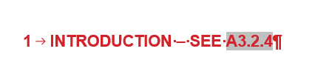
Example:
Example:

Example:
Example:
Category five
this heading will not appear in table of contents
    - Annex headings
Annex ECC Heading 1-4 is used for the sections in the annexes
All headings have margins at 0 cm, justified
Example:
Example:
Example:
Example:
- All headings have the margin at 0 cm, justified;
- Annex ECC Heading 1-4 is used for the sections in the annexes;
- If you need another subheading, please use ECC Heading no numbering;
- Example:
- Category five
- this heading will not appear in table of contents
    - New styles
- Five new additional styles are available in this latest template:
ECC HL bold and blue;
ECC HL bold and italics;
ECC HL italics and petrol;
ECC HL red;
ECC Numbered List level 2.
    - Removing styles
If you need to remove an existing style in body text then highlight the text you wish to update and choose "ECC Paragraph". The style will then be in the ECC Paragraph format, you have to pay attention to update special characters (e.g. subscripts and superscripts). See example below.
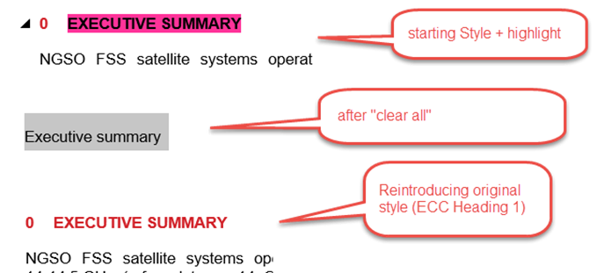
- If you need to remove an existing style in body text then highlight the text you wish to update and choose "ECC Paragraph". The style will then be in the ECC Paragraph format, you have to pay attention to update special characters (e.g. subscripts and superscripts).
    - Example of bulleted lists
- Bullet point level 1 (style: ECC Bullets Lv1);
- Bullet point level 1 (style: ECC Bullets Lv1);
Bullet point level 2 (style: ECC Bullets Lv2);
Bullet point level 2 (style: ECC Bullets Lv2);
- Bullet point level 1 (style: ECC Bullets Lv1);
- Bullet point level 1 (style: ECC Bullets Lv1);
Bullet point level 2 (style: ECC Bullets Lv2);
Bullet point level 3 (style: ECC Bullets Lv3);
- Bullet point level 1 (style: ECC Bullets Lv1).

Example of numbered lists
- Numbered list level 1 (style: ECC Numbered list);
- Numbered list level 1 (style: ECC Numbered list); if you have text below number the following layout is to be used:
  - Number 2a (style: ECC Number List level 2)
    - Example of lettered lists
- Lettered list (style: ECC Lettered List)
- Lettered list (style: ECC Lettered List); if you have text below number the following layout is to be used:
  - Letter list level 2 (style: ECC Lettered List Level 2;
  - Letter list level 2 (style: ECC Lettered List Level 2.
    - List of styles used in the ECC Deliverables Template shown in alphabetical order
- Cover page ‘approved DD MM YY’
This style is used on the cover page only to specify the date of approval of deliverable.
- Cover page ‘last update DD MM YY’
This style is used on the cover page only to specify the last update of deliverable.
- Cover page ‘Report No’
This style is used on the cover page only to specify ECC Deliverable number.
- Cover page ‘Report title/description’
This style is used on the cover page only to specify title of the ECC deliverable.
- Cover page ‘Table of Content’
This style is auxiliary and kept in the list of styles in order to maintain Table of content in the deliverables.
- ECC Annex heading 1 – 4
This style is used for different levels of Annexes heading.
- ECC Bullets Lv1 – Lv3
This style is used for three levels of ECC bulleted list.
- ECC Caption
This style is used for Figure and Table head.
- ECC Editor’s Note
This style is used to show editor’s note and will be always shown with yellow highlight.
- ECC Figure/graph centred
This style is used to position a Figure in the centre.
- ECC Footnote
This style is used only for the footnotes in the documents in exactly the same way as in an ‘unlocked template’ document.
  - ECC Footnote number
This style could be used in case if it is necessary to align numbering of ‘ECC Footnote’.
- ECC Heading 1 – 4
This style is used for different levels of Sections heading.
- ECC Heading no numbering
This style is used for Heading 1 but without numbering.
- ECC HL blue .... and so on
Those styles are used to highlight some text in the document and should be removed from approved deliverables.
Upon requests, ECC has added the following new styles in order to ease work while drafting the Report
- ECC HL bold and blue,
- ECC HL bold and italics
- ECC HL italics and petrol
- ECC HL red
When you want to remove an existing style, highlight the text choose the style ECC Heading or ECC Paragraph
- ECC HL bold, subscript, superscript, underlined
Those styles are used to highlight some text in the documents and can be either kept or removed from approved deliverables.
- ECC Hyperlink
This style is used to highlight a hyperlink.
- ECC Lettered list
This style is used to create a lettered list.
- ECC Numbered list
This style is used to create a numbered list.
- ECC Numbered list, level 2
This style is used for text under ECC Numbered list.
- ECC page Footer and ECC page Header
This is to be used for footers and headers.
- ECC paragraph
This style is used as a body text.
- ECC Reference
This style is used for the list of references.
- ECC Table Header red font
This style is used for ‘ECC table header’ – red coloured letters.
- ECC Table Header white font
This style is used for ‘ECC table header’ – white coloured letters.
- ECC Table note
This style is used for ‘ECC Table note’.
- ECC Table text
This style is used for the Table text.
  - Figures
    - General instructions for figures
- Figure captions are positioned below the figure.
- In the figure caption, only the first letter of the title is capitalised; all other words shall not be capitalised unless they are terms that would normally be capitalised);
- Figure captions are without a full stop at the end;
- Figure captions are advised to be concise as possible, recommended one line. If text is longer than one line, please add the explanation as text before or after the figure;
- The figure and figure title is to be centred by using the style “ECC Figure/graph centered”;
- Figures shall use automatic numbering - Arabic numerals, beginning with 1.. ascending numbering throughout the ECC deliverable, i.e. "Figure 1:";
- Figures are to be inserted “in line with text”
- If two figures need to be next to each other then right click on the figure, select Wrap Text and Square option.
    - How to insert a figure caption
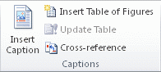
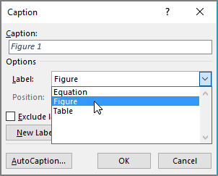

    - Example of a figure
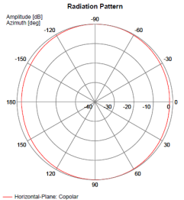
Figure 1: Cab-radio horizontal antenna pattern at 880 MHz
  - Tables
    - General instruction for tables
- Table captions are positioned above the table;
- In the table caption, only the first letter of the title is capitalised; all other words shall not be capitalised unless they are terms that would normally be capitalised);
- Table captions are without a full stop at the end;
- Table captions are advised to be concise as possible, recommended one line. If text is longer than one line, please add the explanation as text before or after the table;
- The table and table caption are to be centred by using the style “ECC Figure/graph centred”;
- Tables shall use automatic numbering - Arabic numerals, beginning with 1.. ascending numbering throughout the ECC deliverable, i.e. "Table 1:";
- Notes shall be descriptive and concise, if more text is needed put it below/above the table;
- Figures are not allowed in table notes, they are to be placed below/above the table;
- If your table needs a different layout such as two red header rows, please contact editorial@eco.cept.org, ECO will fix this and reply within one working day;
- If the table is longer than a page length, the table number and title as well as column headings shall be repeated on each page. The template is designed to apply this automatically;
- Avoid copying and pasting tables as pictures. If this is necessary, add a reference from where the table was copied.
    - How to insert a table caption
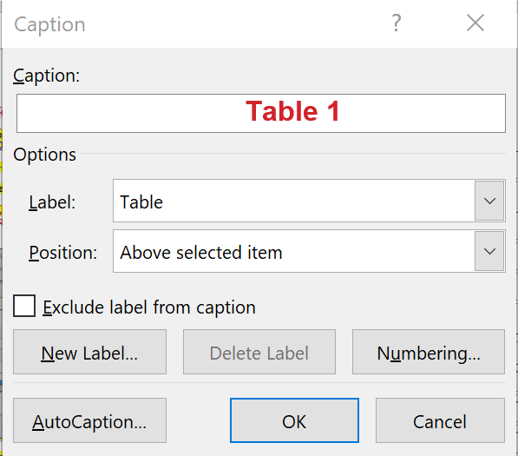
    - How to insert a table
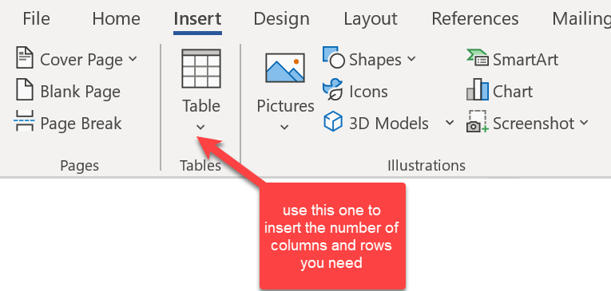
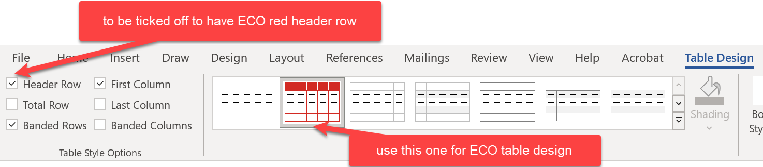

- If this does not work according to your expectations, please contact editorial@eco.cept.org with instructions, ECO will aim to reply within one working day;
    - Information on different kind of tables
Table 1: Standard table format
Table style: ECC Table – red header  Centred margin (Note 1) | Table style: ECC Table – red header  Centred margin
Example of a subheading
Text left margin  Margin 0 cm  Style: ECC Table text | Text left margin  Margin 0 cm  Style: ECC Table text
Text left margin  Margin 0 cm  Style: ECC Table text | Text left margin  Margin 0 cm (Note 2)  Style: ECC Table text
Note without a number refers to the entire table

Note 1: test to be tested, test to be tested, test to be tested test to be tested test to be tested test to be tested test to be tested test to be tested
Note 2: test
Note 3: notes with numbers are to be hanging 1 cm like in note 1 in order to ease readability
Example of a standard table:
Table 2: Requirements on RMR cab-radio receiver characteristics
Parameter | Value
Level of the wanted signal | Sensitivity +3 dB
Maximum 5 MHz LTE interfering signal in 880-915 MHz (Note 1) | -33 dBm (Note 2)
The antenna connector of the radio module is the reference point.
Note 1: This requirement covers both blocking and third-order intermodulation
Note 2: -36.2 dBm for a desensitization of 1.7 dB is equivalent to -33 dBm for a desensitization of 3 dB
Example of an alternative table layout with 2 heading rows:
Table 3: MFCN BS selectivity increase
RMR carrier | MFCN BS selectivity increase
 | compared to  CEPT Report 39 [4] | compared to  TS 137 104 [9]
10 MHz LTE/NR in 1900-1910 MHz | 24.3 dB | 40.6 dB
Example of an alternative table layout with merged cells:
Table 4: LTE/NR FRMCS high-power cab-radio characteristics
Parameter | FRMCS BS  900 MHz range | FRMCS BS  1900 MHz range |  | Reference
Channel bandwidth | LTE: 1.4 or 5 MHz  NR: 5 MHz | 10 MHz | ETSI TS 136 101 [10]  ETSI TS 138 101-1 [11]
 | NR: 5.6 MHz |  | Note
Occupied bandwidth | LTE: 1.08 or 4.5 MHz  NR: 4.5 MHz | LTE: 9 MHz  NR: 9.36 MHz | ETSI TS 136 101 [10]  ETSI TS 138 101-1 [11]
 | NR: 5.04 MHz |  | Note
Maximum output power | 31 dBm with UL power control |  | Railway industry’s request
Maximum e.i.r.p. | 33 dBm with UL power control
ACLR | 37 dB |  | ETSI TS 136 101 [10]  Power Class 1 (note 1)
Note: The 5.6 MHz channel bandwidth is considering a transmission bandwidth of 28 RB between 919.6725 and 924.7125 MHz, reflecting a possible 5.6 MHz NR channel. This is understood to be compatible with NR lower layers, subject to additional standardisation work, as necessary, to confirm and further specify this.
Note 1: For a Power Class 3 UE, ACLR is 30 dB.
  - Equations¨
    - General information about equations
- Equation numbers are placed in brackets with right margin
- Equations should use the in-built equation tool to provide a consistent format.
- References to equation symbols in text should use italics
- All equations are to have automatic numbering before approval for public consultation
    - Instructions for Equations with automatic numbering
Method 1 (copy existing template):
- Copy and paste the entire frame below and edit as necessary;
- Right click the equation number, “(1)”- and select “update field”

$$Type equation here.$$ | (1)

Method 2 (save template to gallery):
- Copy the entire frame above
- Select Insert->Equation->Save Selection to Equation Gallery. Choose a suitable name, e.g. “ECC Equation”
- The numbered equation template will now be available for all new documents on your computer under Equation -> General (below the Built-In list)
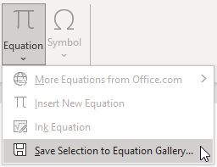
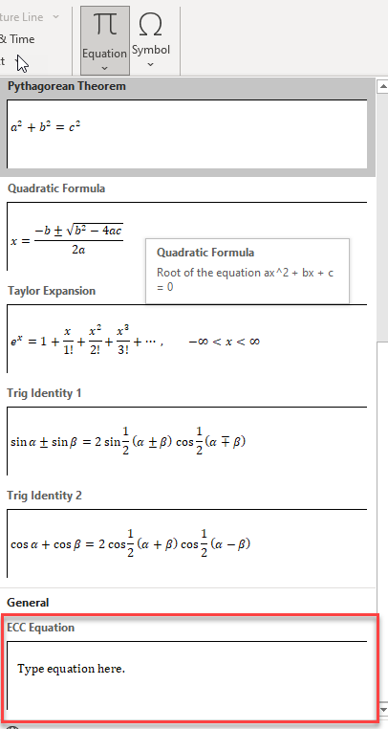
    - Example of an equation
The total permitted interference:
 | $$=N+10\log_{10}\left({10}^{\frac{D}{10}}-1\right)$$ | (2)
Where:
- I_{IB} is the total permitted interference at the antenna connector in dBm;
- D is the acceptable degradation in receiver sensitivity, or desensitisation, in dB;
- N is the receiver thermal noise power in dBm.
  - Flow of ECC deliverables
